How to modify a reservation for an event using the SCA reservation system
If there is already a group reservation in place, only the person that made the reservation may change it. If you made your own reservation this is how you may change it.
Go to the SCA website and click Event Reg
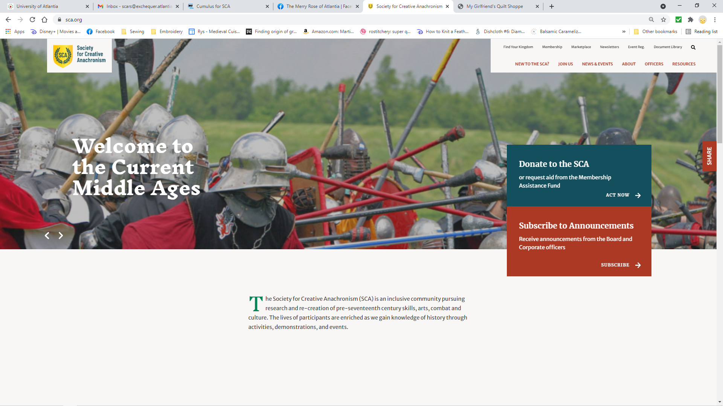
Use the dropdown to select the Kingdom holding the event you wish to attend.
Click event details to the right of the event to select the event you wish to attend. If is not shown verify you are in the correct Kingdom or if registration is closed.
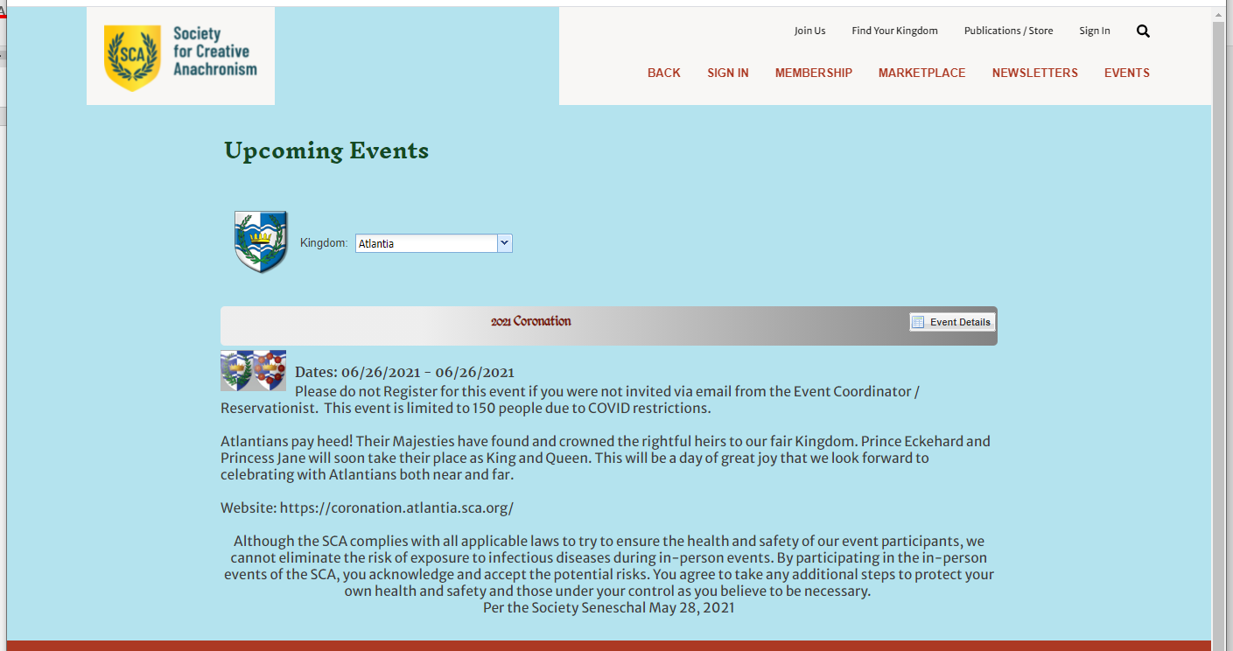

If this is the event you wish to modify click Register.
At this point you will need to log in to your account (non-members keep the information provided when you create your account for future reservations).
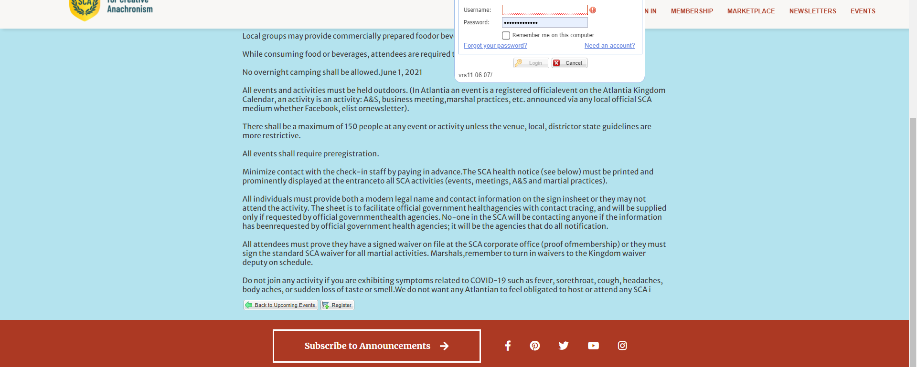
The system will remind you that you are already registered for this event. Click view Registration.
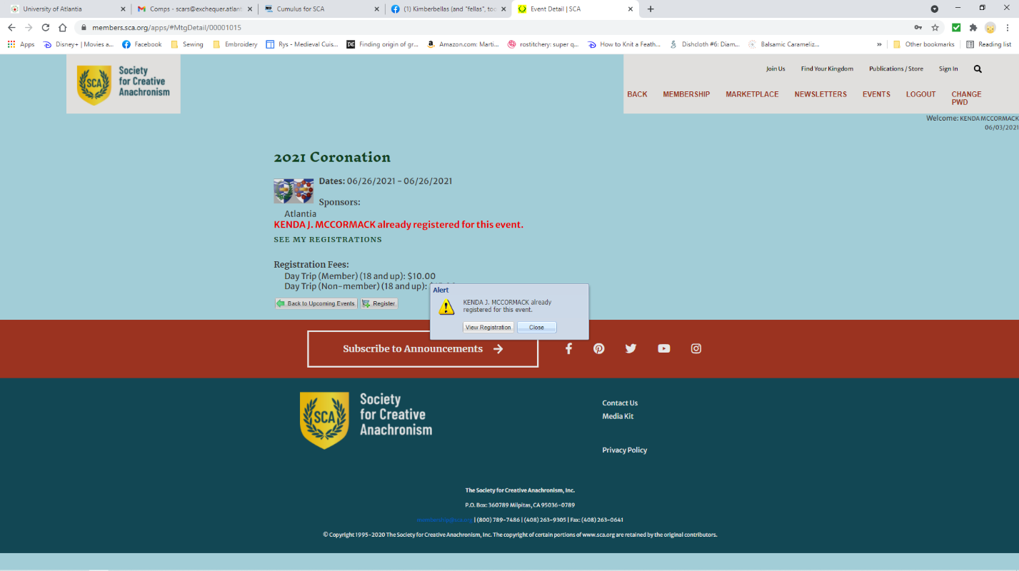

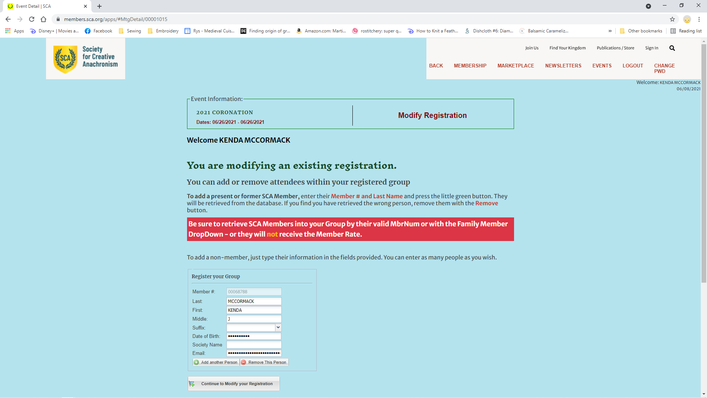
When adding additional people, click add another person. If you just wish to modify your registration click Continue to Modify you Registration.
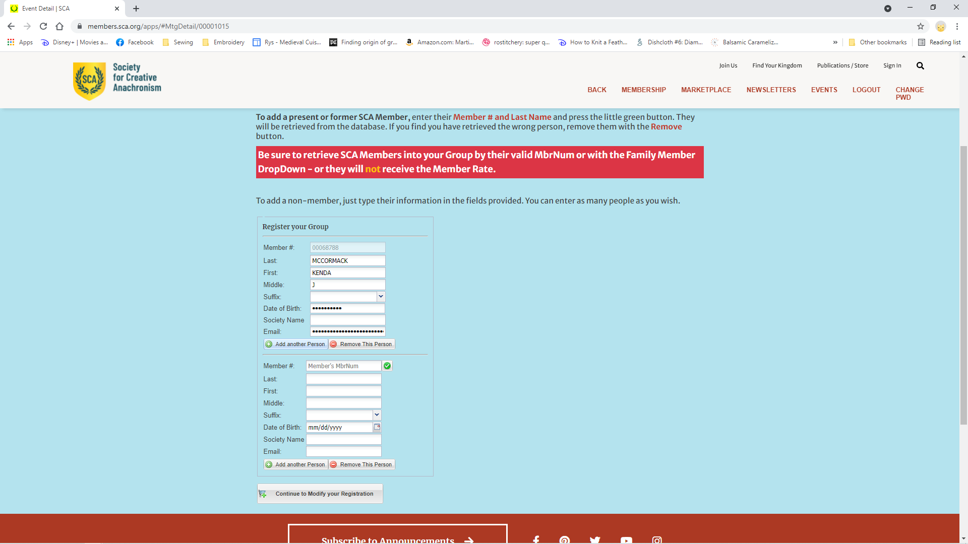

If you have a membership number and if you enter the membership number first it will give you an error to enter the last name.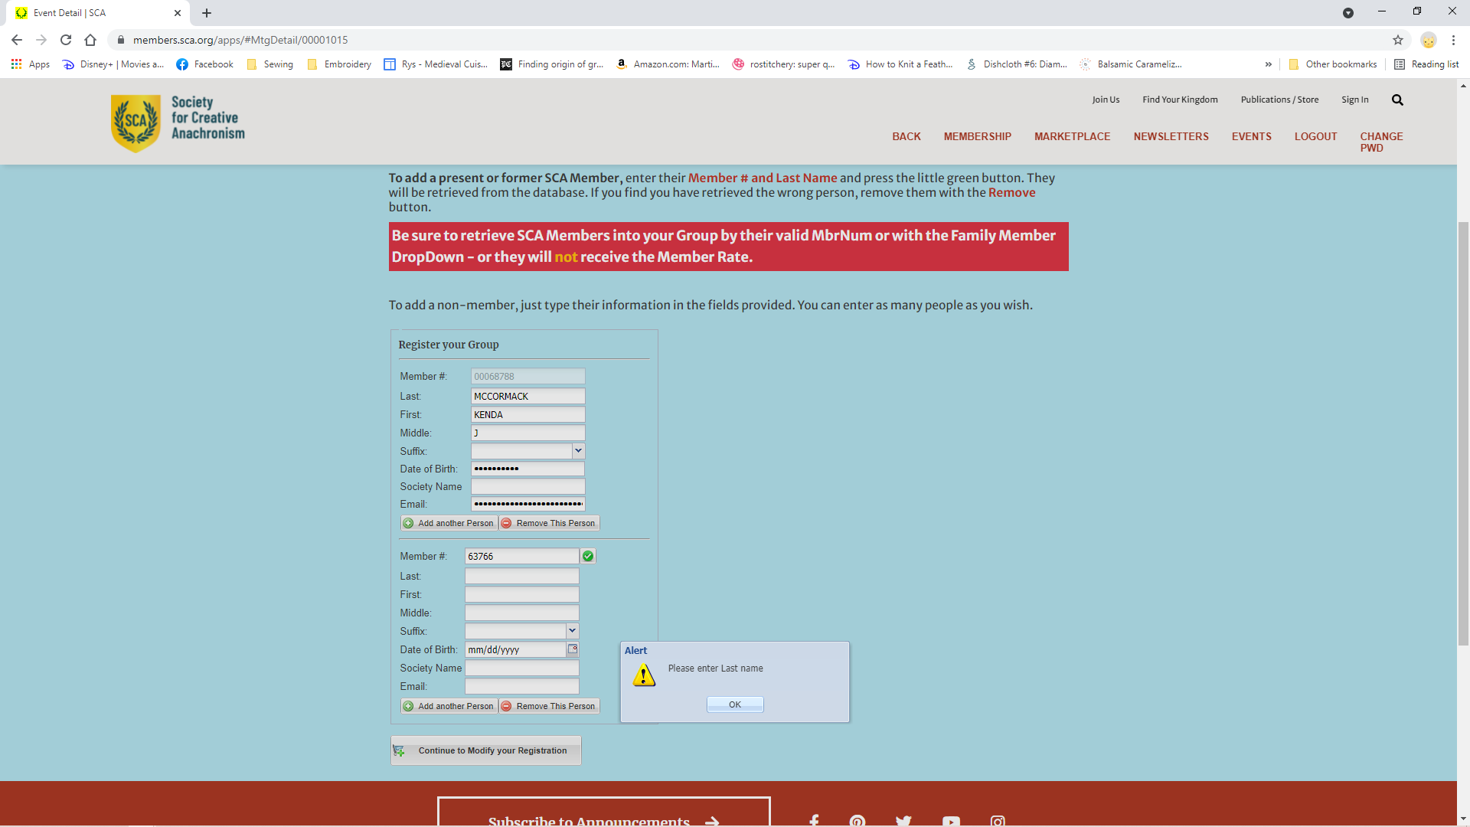
Once you have entered both pieces of information, click the green check box next to the membership number. This will make the system verify and pull up the corresponding information.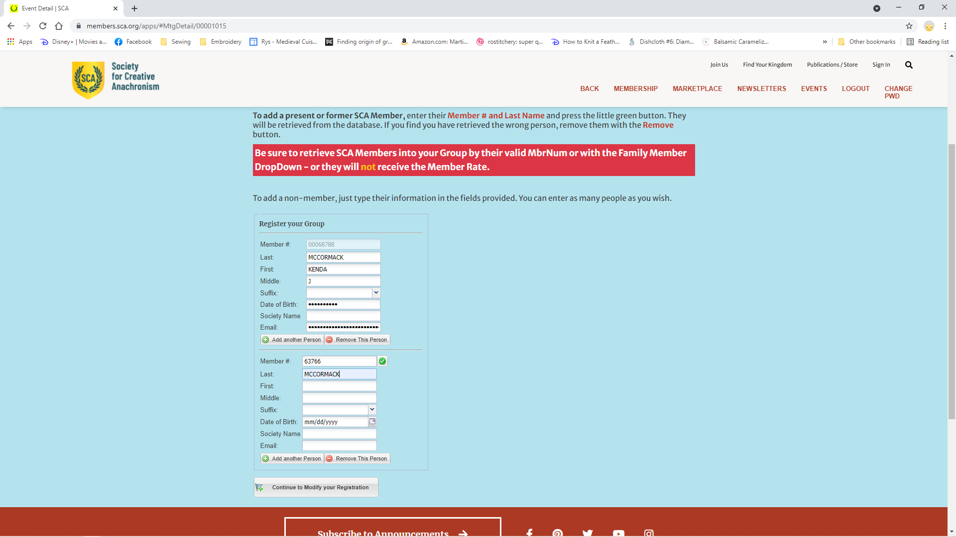

It will bring in the information with date of birth and email address hidden.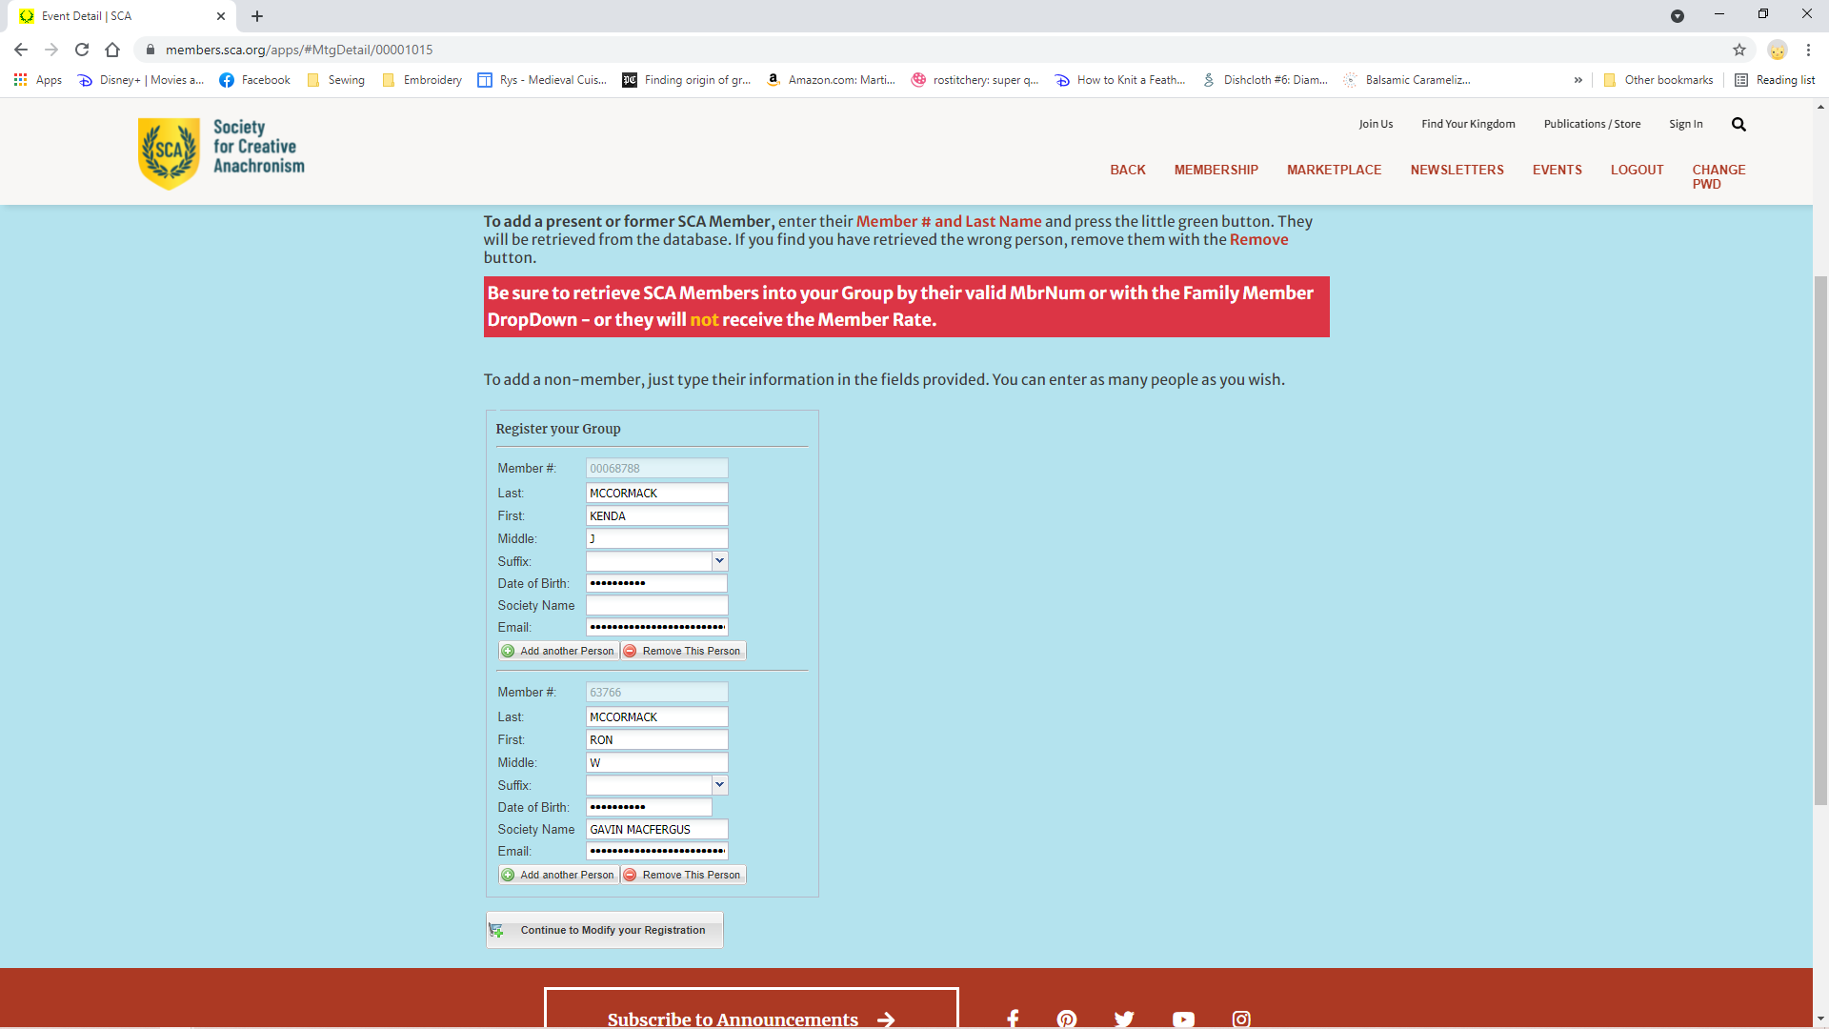

If there are options to choose, like feast or lodging, it will then display a screen for you to select for each reservation. Select what you wish to include and when complete click Add to Cart.
Emergency Contact information may be provided but is not always required. The system will provide an error box if it is required.
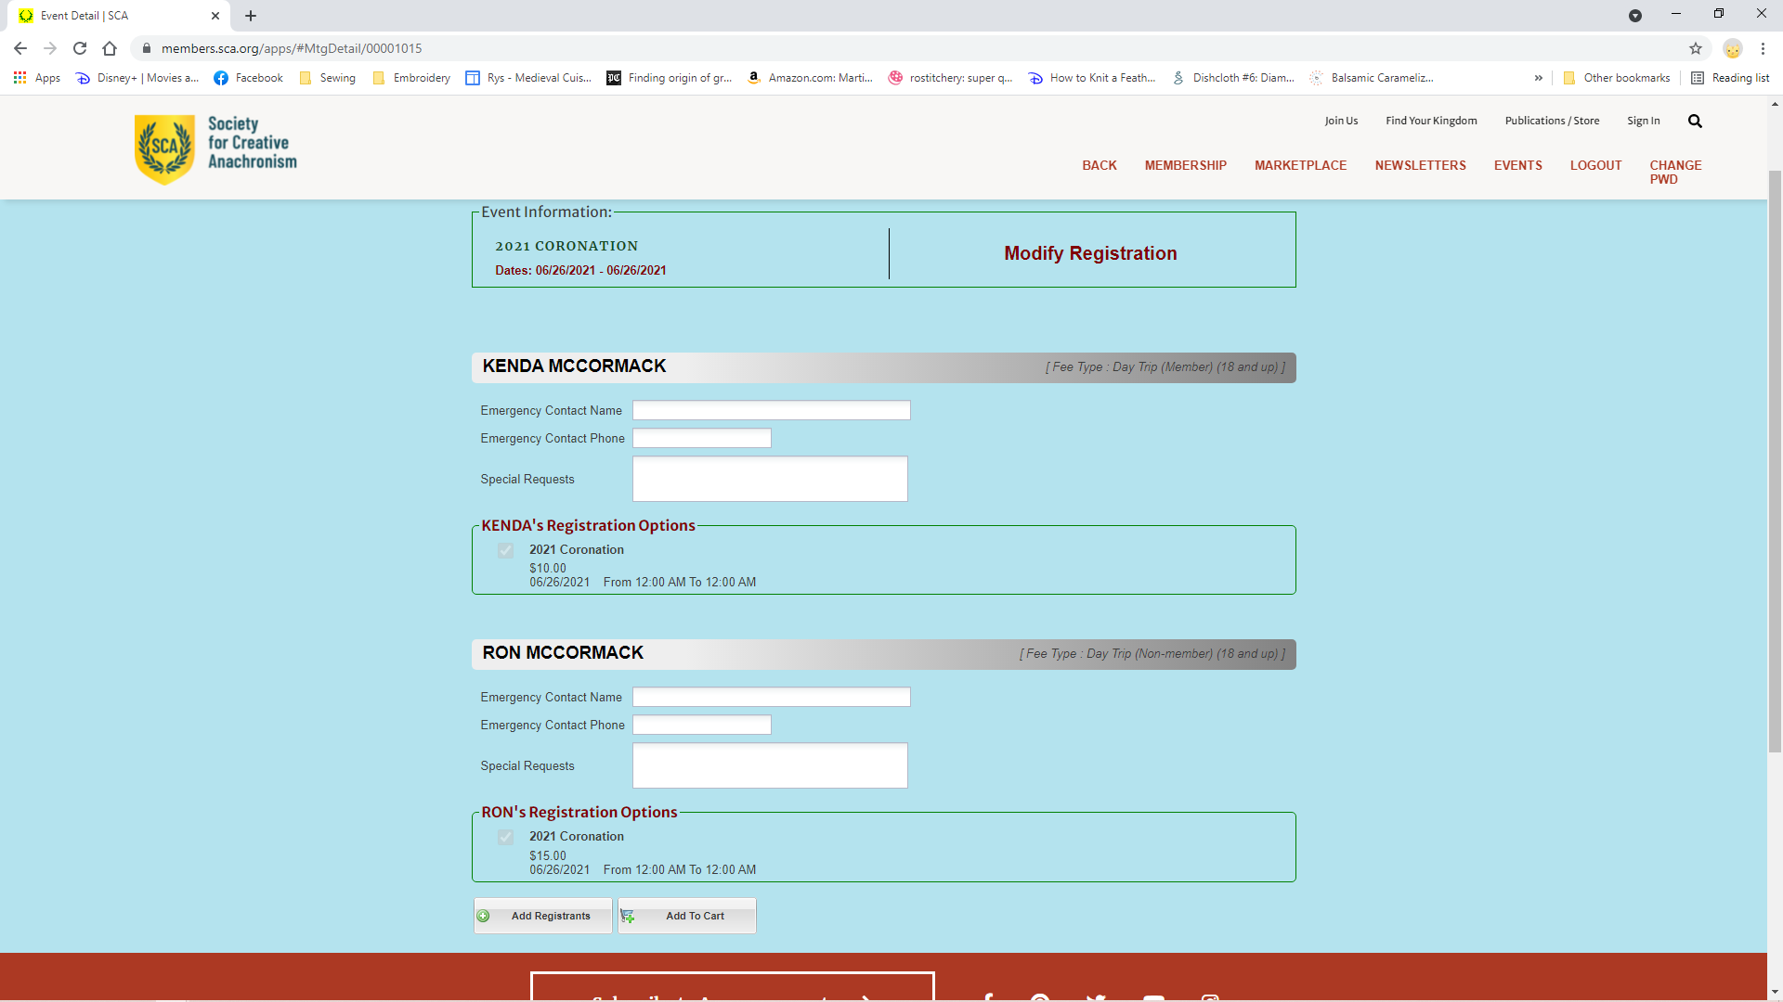

Once you click Add to Cart you will be taken to the payment screen. It will show the amount the registration has changed either you will be charged for the additional amount, or a credit. Refunds will not be made to your credit card, but by check from the event.
The billing information will be completed based on your membership number. But the payment information is not kept.
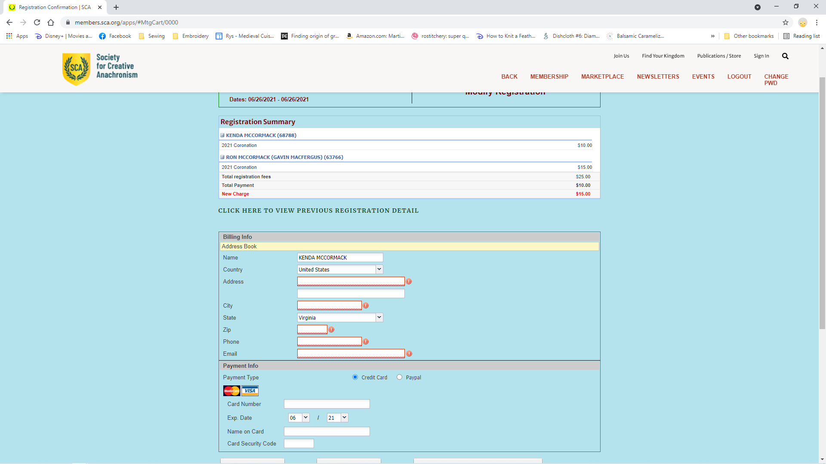
Click Submit Payment and complete registration.
An email confirmation is sent to the email address you provide for each registered participant.

