How to register for an event using the SCA reservation system
Go to the SCA website and click Event Reg
Use the dropdown to select the Kingdom holding the event you wish to attend.
Click event details to the right of the event to select the event you wish to attend. If is not shown verify you are in the correct Kingdom or if registration is closed.
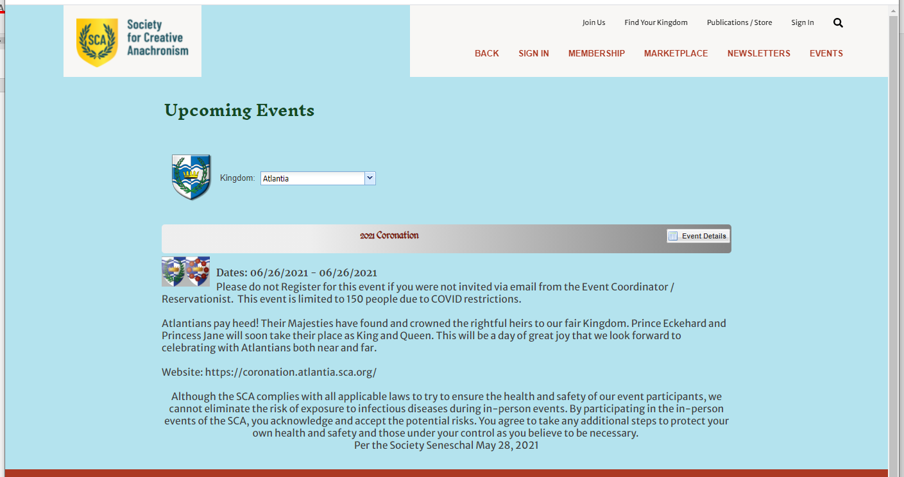

Read the short information blurb, if this is the event you wish to attend click Register.
At this point you will need to log in to your account (non-members keep the information provided when you create your account for future reservations).
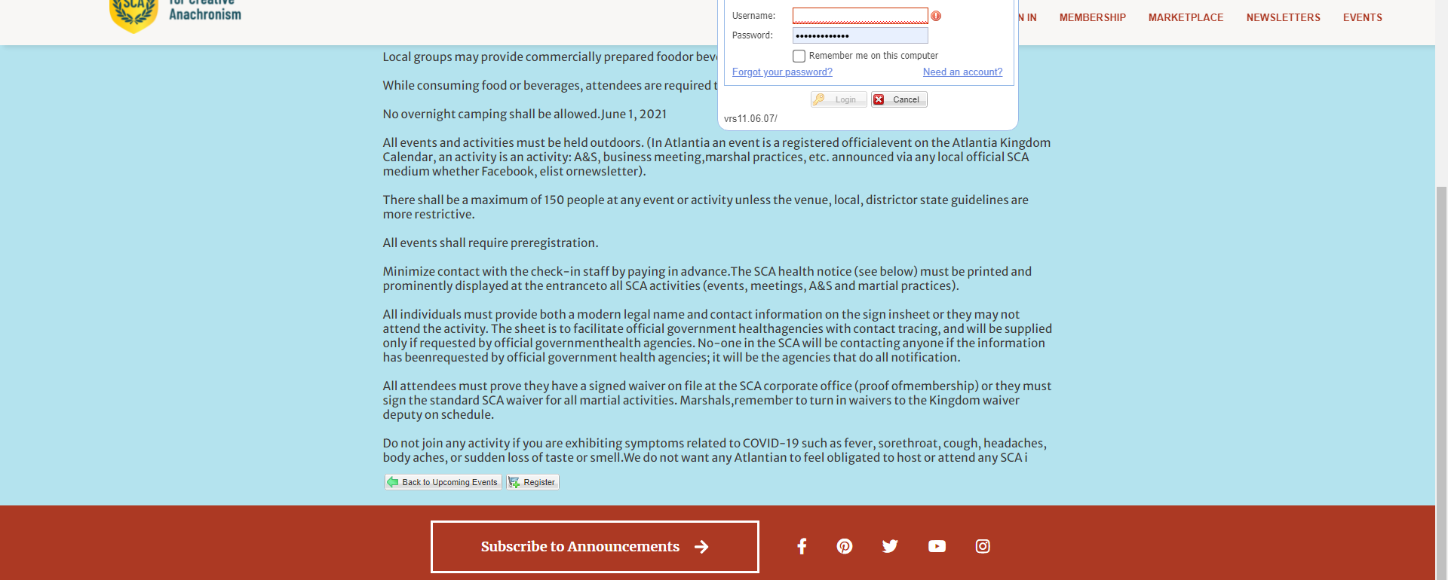
You will always need to register the person who signed in first, but you may also register a group of people.
For Members: You will need their membership # (for member price), Last Name. If the member has not put an email address in the system you will have to add one for the registration to continue.
For Non-Members: You will need their First and Last Name, date of Birth (for age pricing) and an email for the confirmation to go to. 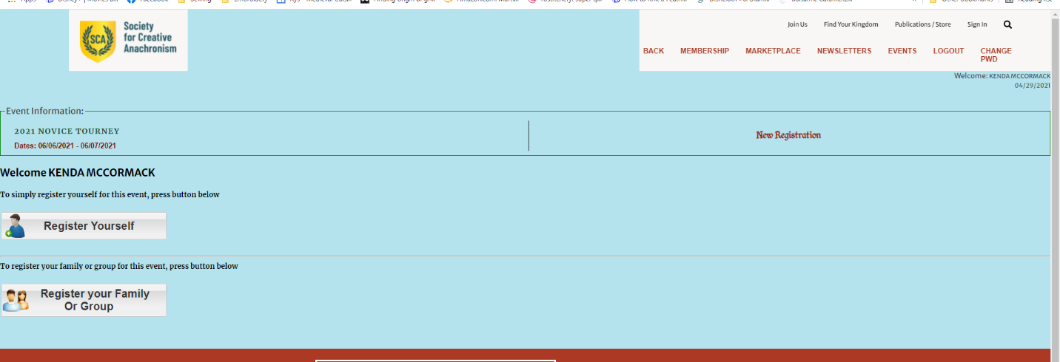
Only the person who creates the registration may change it, so if someone within the group can’t go, the original person will have to change the registration.

When registering yourself, once you verify the information, it will take you straight to the selections page and show your site fee amount already selected. Ensure you delete any empty registration boxes, and click Add to cart.
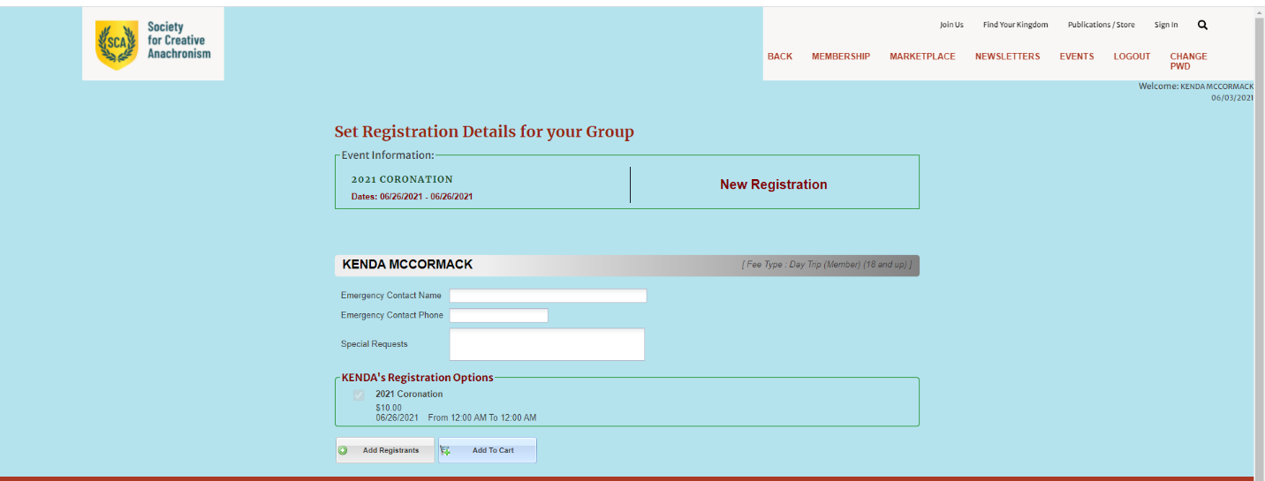
If registering a group, click Register your group.
When adding a member: you must enter enter the last nme then the number and click the green check mark for it to verify in the system and pull up the individuals information. The date of birth and email will be hidden.
When adding a non-member, you must enter the first and last name, date of birth (for age pricing) and an email address.
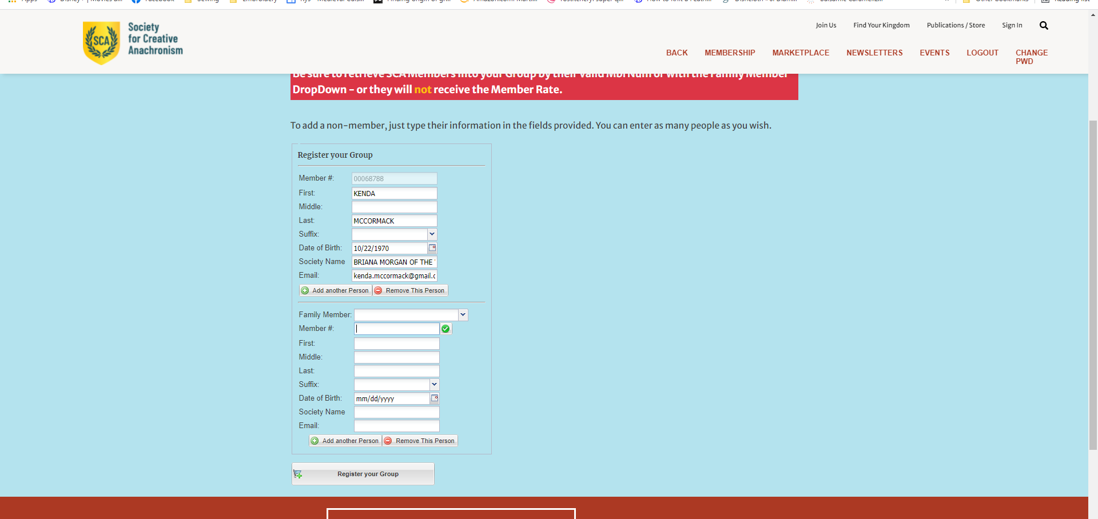
If you have a membership number and if you enter the membership number first it will give you an error to enter the last name.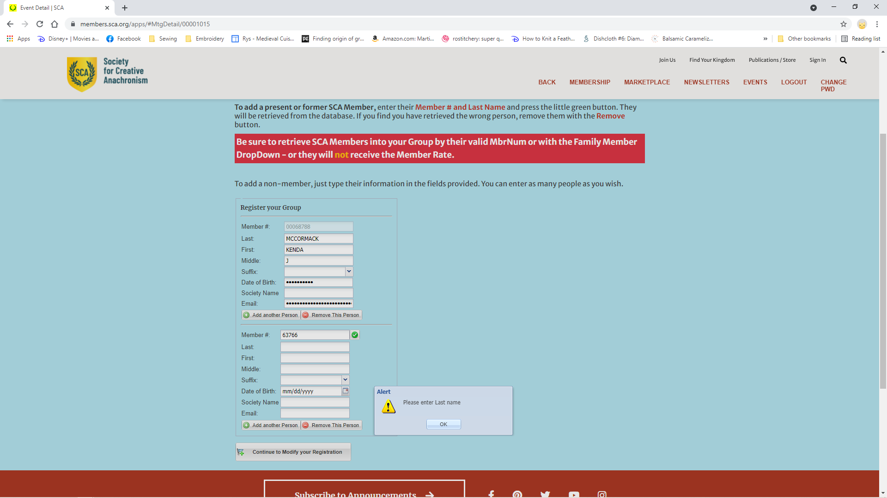
Once you have entered both pieces of information, click the green check box next to the membership number. This will make the system verify and pull up the corresponding information.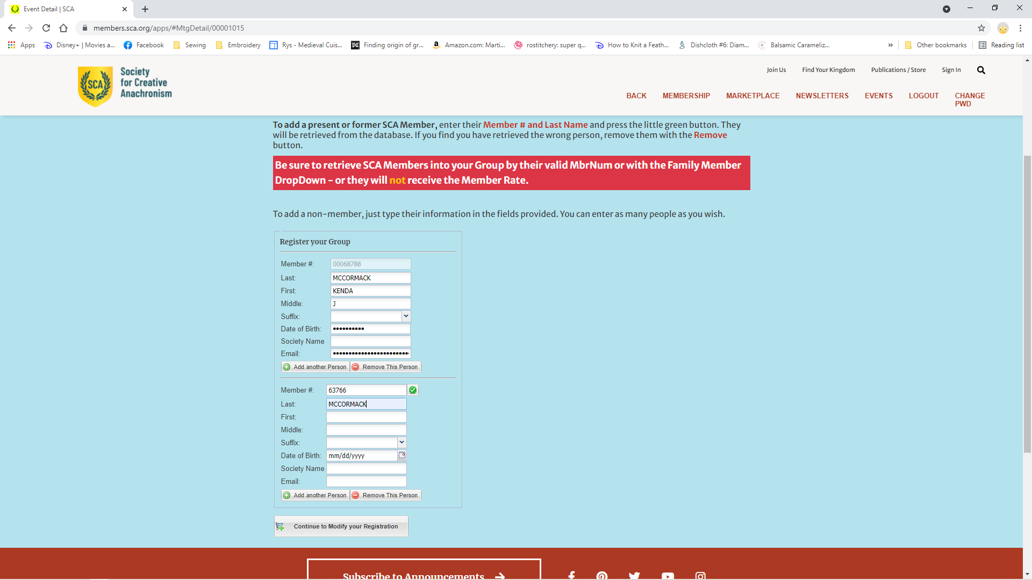
If you are done adding registrants, remove any blank registration requests.
If the person was a member but their membership is not current, the cost will reflect the current membership status.
If there are options to choose, like feast or lodging, it will then display a screen for you to select for each reservation. Select what you wish to include and when complete click Add to Cart.
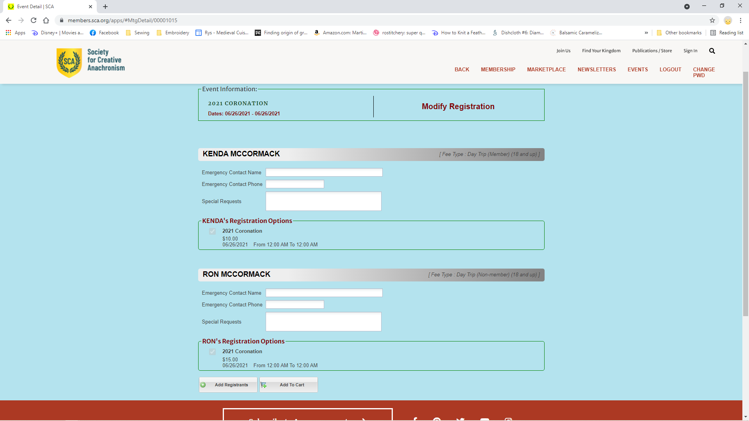
Once you click Add to Cart you will be taken to the payment screen. It will show the amount the registration has changed either you will be charged for the additional amount, or a credit. Refunds will not be made to your credit card, but by check from the event.
The billing information will be completed based on your membership number. But the payment information is not kept.
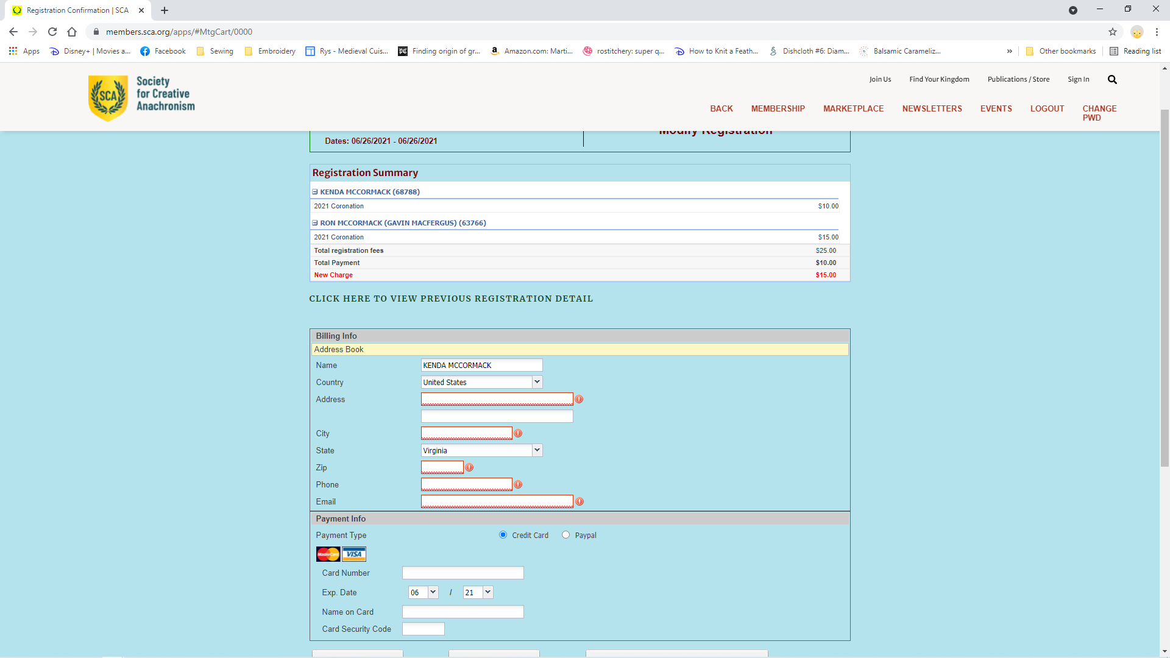
Click Submit Payment and complete registration.
An email confirmation is sent to the email address you provide for each registered participant.

